Generate & Print Compensation Statements
Note: To generate a compensation statement, there are 2 prerequisites:
- Compensation forms must be in the “Completed” step.
- The employee must be eligible to receive Compensation Statements (“TRUE” in “RECEIVE_COMP_STMT” employee file column)

1. Generate Compensation Statements
You only need to perform the “Generate Compensation Statements” steps one time (unless comp data is changed). Once statements are generated, you do not need to perform these steps to print statements. To print statements, go directly to the “2. Print Compensation Statements” steps below.
1. In Admin Center, in Compensation, click Action for all plans.
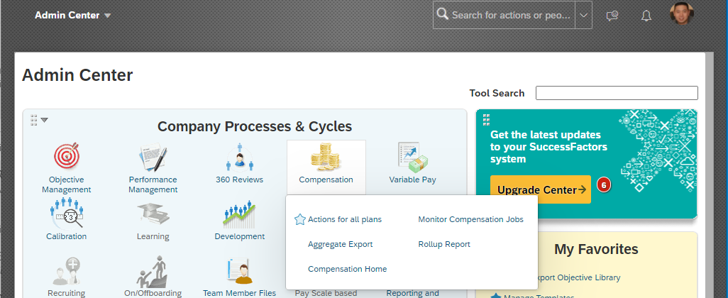
2. Click on the current year compensation form.
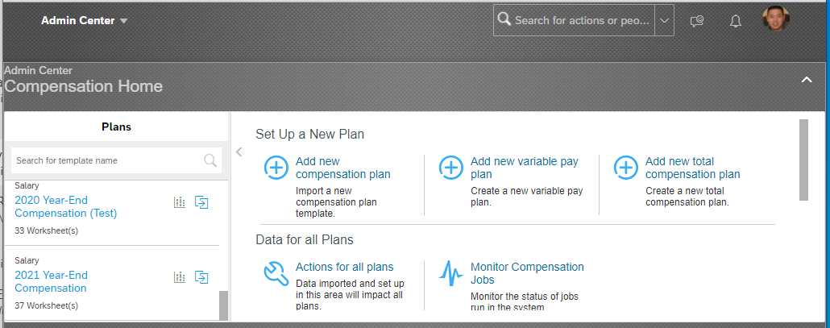

3. Click the Manage Worksheets tab.
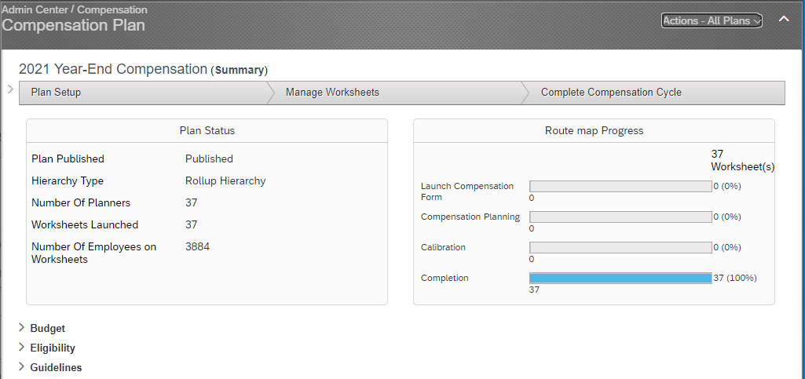
4. Click Generate Statements.
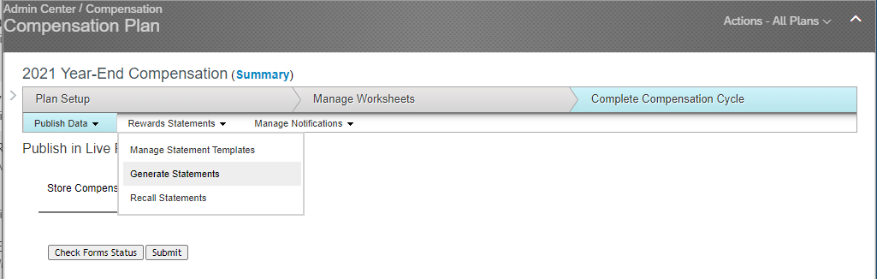

5. Click Select by employee name or Select by list of usernames.
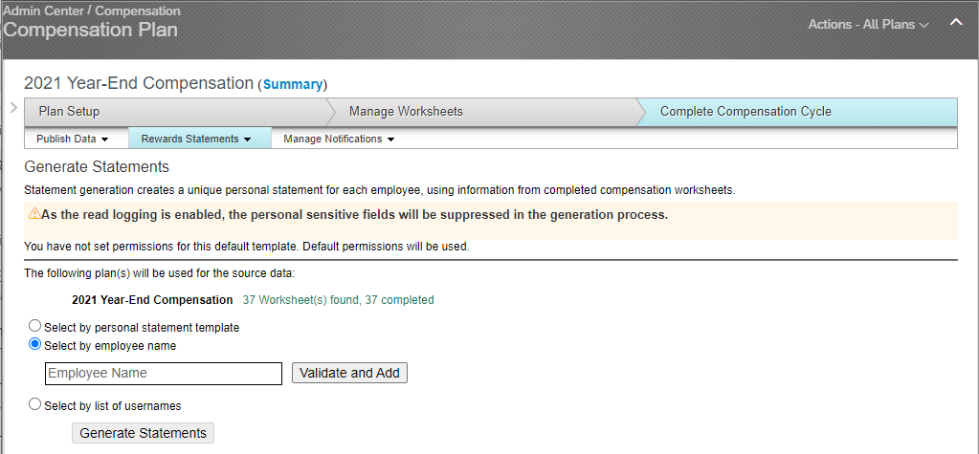
6. Click Validate and Add.
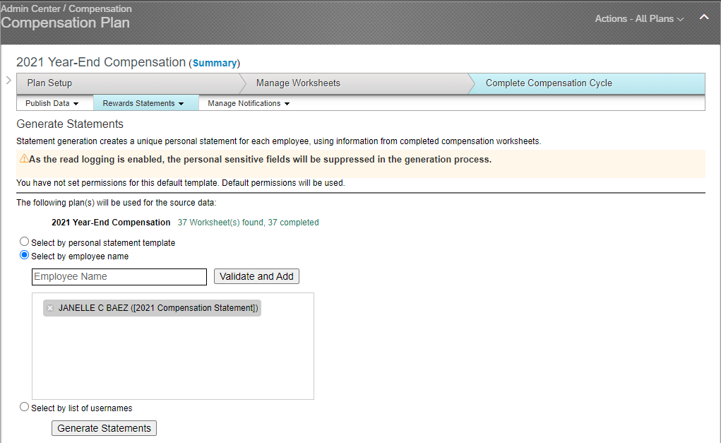

7. A message will appear to tell you that statements are being generated. You will receive an email as soon as the statements are generated.
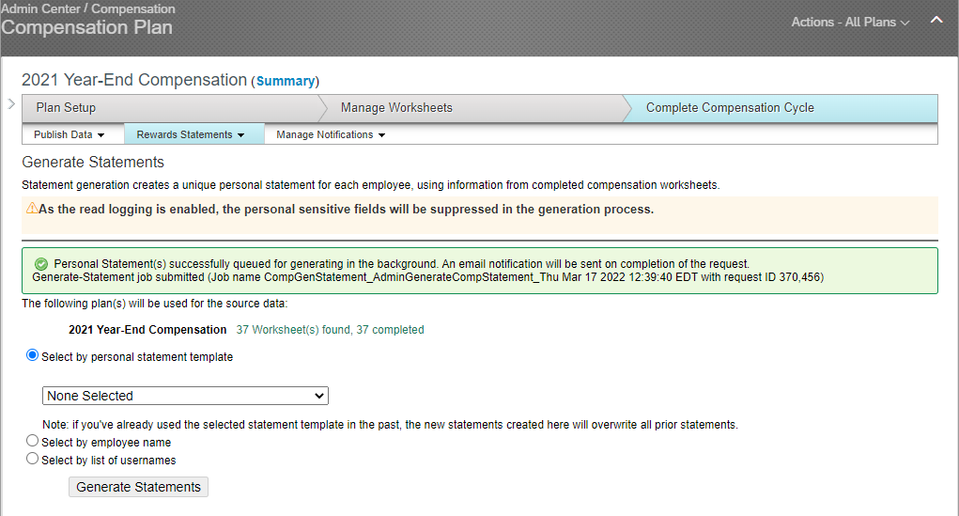
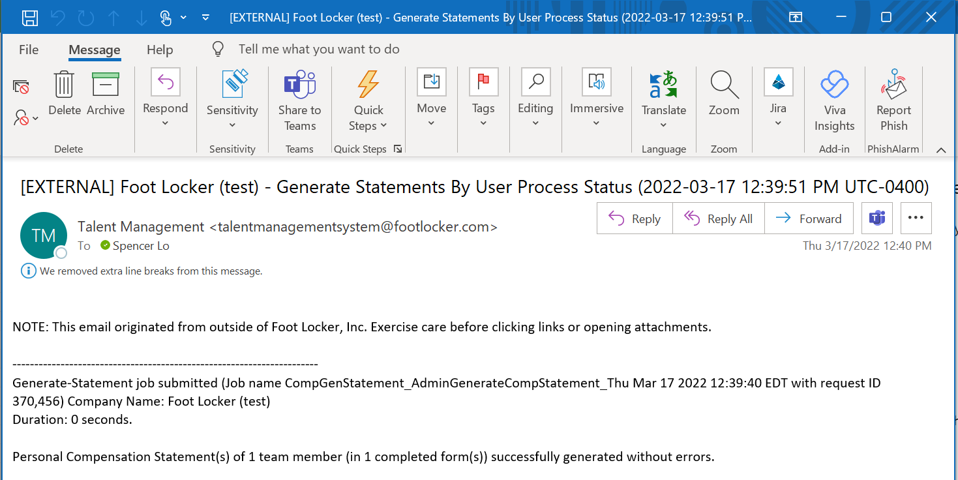

2. Print Compensation Statements
1. In Admin Center, in Compensation, click Action for all plans.

2. Click View User Personal Statements
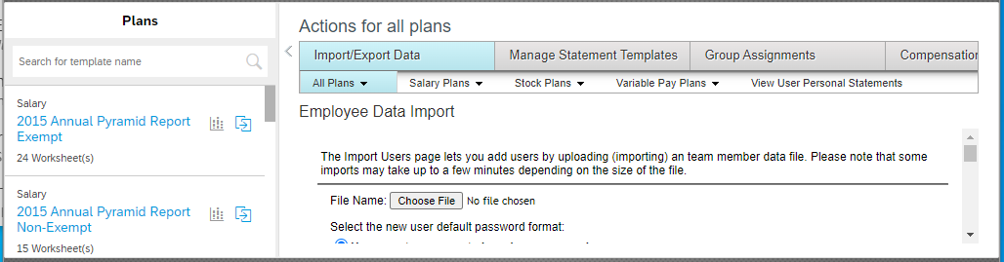

3. Enter statement parameters.
- User Search: employee name
- Statement Type: “Compensation Statements”
- Start/End Date: Enter the current month.
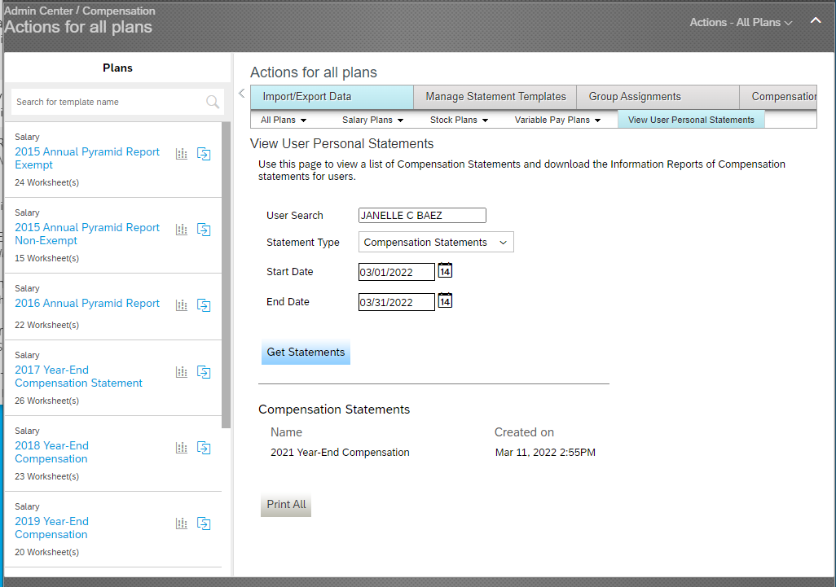
4. Click Get Statements.
5. Click Print All to view the statement.
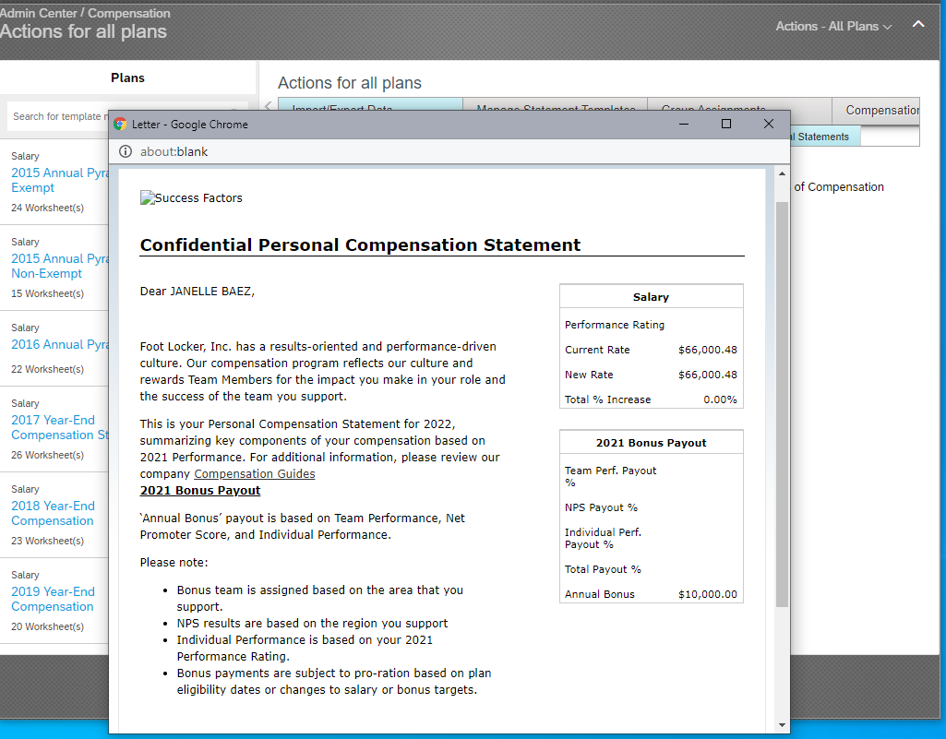

END

